Annual York Audubon Banquet
WHEN: Saturday, April 2, 2022
WHERE: East Berlin Area Community Center
405 North Avenue, East Berlin, PA 17316
COST: $22 per person prepaid by March 26th
$25 (cash only) at the door
Reservations required.
Come early for our silent auction, raffle, 50/50 and socializing with members.
Doors open at 4:00.

TIME: Dinner served at 6:00.
MENU
Served Family Style

Baked Chicken
Baked Ham
Scalloped Potatoes
Candied Carrots
Green Beans

Dinner Roll
Cranberry Sauce
Homemade Fruit Pies
and Ice Cream
Iced Tea, Ice Water and Coffee

_____________________________________________________________________

YAS presents Middleton Evans as he shares his
latest book which highlights exquisite photos and
a comprehensive handbook to the mid-Atlantic
region. The book is titled: “Birds of Maryland,
Delaware and the District of Columbia”. Middle-
ton will have books for sale.
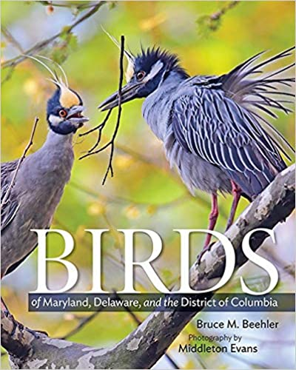

Make checks payable to York Audubon Society. Mail to Bernie Frick, 168 Springdale Rd, York, PA 17403. Reservation dead-
line: Mar. 28, 2022. Bernie’s phone # is 717-843-6675. $25 CASH ONLY at the door for last minute attendees.
- - - - - - - - - - - - - - - - - - - - - - - - - - - - - - - - - - - - - - - - - - - - - - - - - - - - - - - - - - - - - - - - - - - - - - - - - - - - -
I, ___________________________________________________ am attending the YAS annual
banquet. Enclosed, please find my check for $____________ to cover the cost for myself and
_________ guests.

